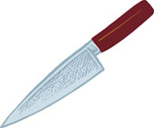

The aim of the study is...

Factors Affecting the Accuracy of EWT

The Weapon Focus Effect (Loftus, 1979)

**Results Condition One:**

**Condition One:**

The conclusion is...

**Results Condition Two:**

**Condition Two:**