Spot the mistakes! – Loftus (1979)
Positive
- Laboratory experiment ~ high degree of control over IV.
- Supported by Deffenbacher (1983)
Negative
- Contradictory findings from research in real-life settings.
Aim: This study aimed to investigate effect of anxiety levels on the replication of eyewitness testimony

Procedure: Field experiment

Loftus (1979) asked participants to wait outside a gymnasium before the study began.
- Condition 1 heard what they believed to be an amicable discussion about equipment failure, after which a man came out with greasy hands, holding a hamburger.

- In condition 2, the participants heard a hostile discussion, followed by the sound of breaking glass and overturned furniture. The man then emerged from the laboratory holding a knife covered in blood.

- The participants were asked the next day to identify the man from 70 photographs.

Findings:
People who had witnessed the peaceful scene were less accurate in recognising the man than the participants who had witnessed the more violent scene (the woman emerging from the room holding the blood-stained knife).

Conclusions: Loftus believed that the anxiety caused by the door (i.e., blood –stained knife) narrowed the focus of attention for the witness and took attention away from the face of the man – therefore making their recall (EWT) less detailed and less accurate.
The knife became the lost detail and was what the participants focussed on and the man’s face became peripheral detail, which meant that it was unlikely that it would be remembered accurately.

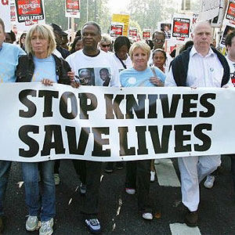
Spot the mistakes! – Loftus (1979) Teacher’s
Positive
- Laboratory experiment ~ high degree of control over EVs.
- Supported by Deffenbacher (1983)
Negative
- Contradictory findings from research in real-life settings.
Aim: This study aimed to investigate effect of anxiety levels on the accuracy of eyewitness testimony

Procedure: Laboratory study

Loftus (1979) asked participants to wait outside a room before the study began.
- Condition 1 heard what they believed to be an amicable discussion about equipment failure, after which a man came out with greasy hands, holding a pen.

- In condition 2, the participants heard a hostile discussion, followed by the sound of breaking glass and overturned furniture. The man then emerged from the laboratory holding a knife covered in blood.

- The participants were later asked to identify the man from 50 photographs.

Findings:
People who had witnessed the peaceful scene were more accurate in recognising the man than the participants who had witnessed the more violent scene (the man emerging from the room holding the blood-stained knife).

Conclusions: Loftus believed that the anxiety caused by the weapon (i.e., blood –stained knife) narrowed the focus of attention for the witness and took attention away from the face of the man – therefore making their recall (EWT) less detailed and less accurate.
The knife became the central detail and was what the participants focussed on and the man’s face became peripheral detail, which meant that it was unlikely that it would be remembered accurately.

