Social Change
What is Social Change?
All the research that we have looked at in class so far has focused on how the majority (a larger group) of people affects the minority (a smaller group of people).
I want to fit in/ I feel that the majority are right in their view

I will join the majority

We all believe that it is important to be a vegetarian

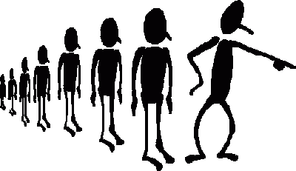
Minority joins the majority

Social Change is when a minority (a smaller group) has an impact on the majority (a larger group). Members of the majority start to believe that the minority are right in their view and so leave the majority group and join the minority. Eventually the _______________ will become the _________________

Example of Social Change:
I believe that it is important to recycle

We must look after the environment

We all believe that recycling isn’t important

- I’m not changing my mind
- It is important to look after the environment
- I’m going to show people how easy it is to recycle

Social change happens when the minority eventually becomes the majority
Majority gradually joins the minority
Maybe the minority is right, it is important that we look after the planet.

- Can you think of any other examples of Social Change (when a small group of people (the minority) has had an impact on the majority (a larger group of people))?

- From the different pieces of research that we have looked at in booklets 1 and 2, from the theories of why we obey and conform, and from the research that we have looked at into independent behaviour, what characteristics do you think are important in bringing about social change?

Imagine you are advising the suffragettes how they can have an impact on the majority and get members of the majority to join their smaller group – what advice would you give them?

