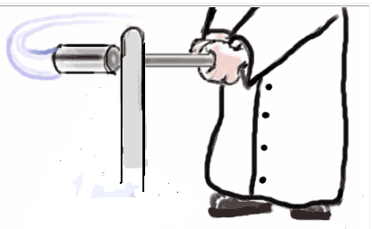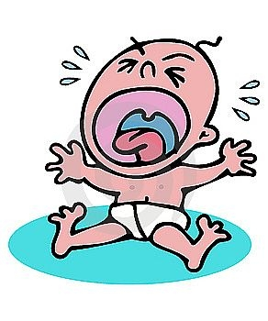

**Neutral Stimulus**

**Conditioned Response**

**Conditioned Stimulus**

**Unconditioned Response**

**Unconditioned Response**

**Unconditioned Stimulus**

**Unconditioned Stimulus**