**Obedience**

**Obedience**

A01 - description

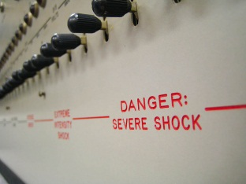

**Research conducted by:**

**Aim:** To investigate whether the Germans were different or if anyone is capable of blind obedience of an authority figure

**Procedure:**

* 40 male participants collected via volunteer sample Lab study, teacher – learner situation (participant was always the teacher)
* He used a fake set up whereby the _________ participant, playing the role of the _______________, was instructed by an authority figure (the experimenter) to punish the learner (by ______________ shock) for incorrect responses on a _______________ test.
* The shocks ranged from **______** (labelled ‘slight shock’) and **increasing in ______** increments to **_______ (labelled XXX).**
* Milgram was interested to see how far the participants would go in order to comply with an _______________ order (to deliver an electric shock to another human) from an authority figure.

**Findings:**

100% of the participants =

63% of the participants =

Participant reactions -

**Conclusion:**

Milgram was therefore able to conclude that ______________ are ______ different and in fact we are all capable of __________ obedience to unjust orders due to the _________________

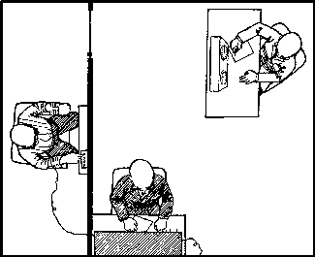

**Point:** The study can be criticised for being *androcentric*

**Evidence:**

**Evaluation:**

**Point:**

**Evidence:** **For example Orne & Holland** suggested that participants in Milgram’s study only administered the shocks because they didn’t believe they were real.

**Evaluation:**

**Potential Evaluation**

**Point:**

**Evidence:** **For example, Hofling (1966)** conducted a study in a hospital. Nurses were telephoned by a ‘Dr Smith’ who asked that they administered a drug to a patient. This order went against hospital regulations in a number of ways; (1) nurses were not supposed to take instructions over the phone, (2) the instructions were from an unknown doctor and (3) the dosage of the drug was twice that advised

**Evaluation:**

A03 - evaluation