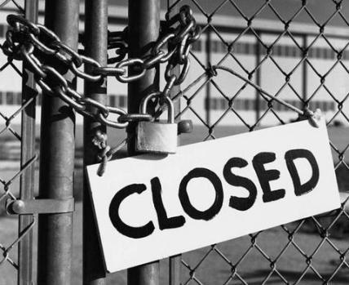Steve has recently lost his job as a building site inspector due to his company going into receivership because of the recession

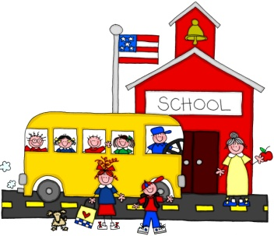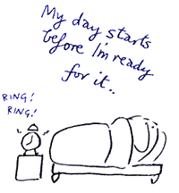Julie suffers from depression,

she works as a full

time teaching assistant and manages a family with 3 children

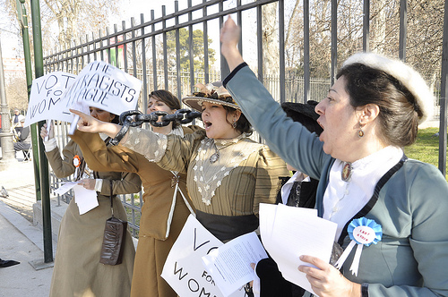Rebecca disagrees with a cosmetics company testing products on animals and so chains herself to the railings

and refuses to eat