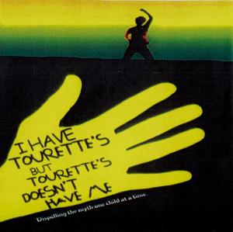

**Point:** Social norms are culturally dependent.

**Example:**

**This is a limitation because:**

**Point:** The DSN definition doesn’t distinguish between deviant behaviour and mental illness

**Example:**

**This is a limitation because:**

**Point:** Social norms change over time.

**Example:**

**This is a limitation because:**

**Description (A_ _)** (*Here have information about what makes an individual abnormal)*

**Social Norms –**

**Someone is abnormal when…**

**Link to a disorder: ________________________________________________ Link:** *(give examples of behaviour)* **_______________________________________________ ________________________________________________________________________**