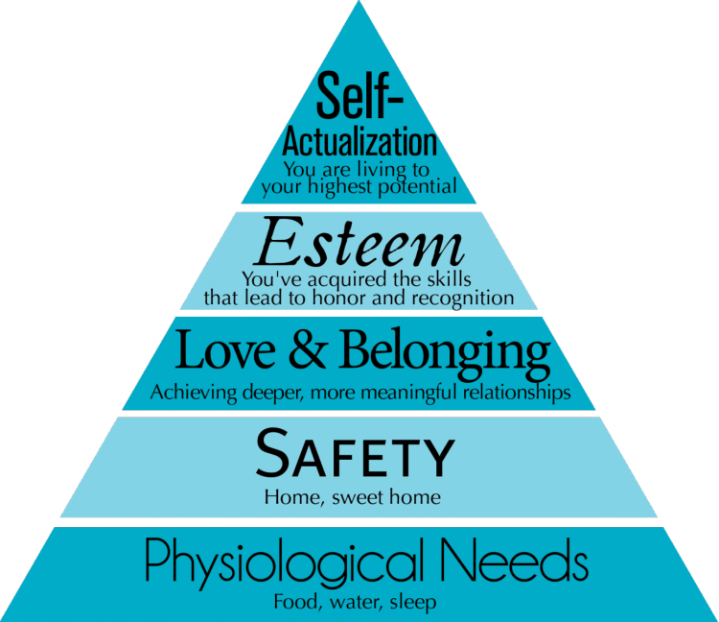
Very few people achieve self-actualisation, the criteria in order to meet
it is set very
high
Colin lacks 2 criteria for ideal mental health, however Ingrid lacks 4 characteristics. Are they both considered abnormal?

Individualistic: Cultures that place their emphasis on personal achievement
Collectivist: Cultures that strive for the greater good of the community.

Which culture would be seen as abnormal according to Jahoda’s criteria?

