Cognitive explanation and treatment of depression ESQs
Q1. Complete the diagram below, by filling in A and B, to show Beck’s negative triad as it is used to explain depression.
Beck’s negative triad
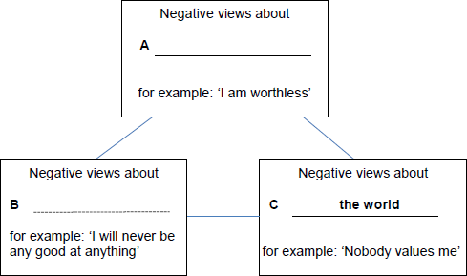
(Total 2 marks)
Q2. Briefly outline one strength of the cognitive explanation of depression.
.................................................................................................................................
.................................................................................................................................
.................................................................................................................................
..............................................................................................................................(2)

Q3. Outline cognitive behaviour therapy as a treatment for depression.
.................................................................................................................................
.................................................................................................................................
.................................................................................................................................
.................................................................................................................................
.................................................................................................................................
.................................................................................................................................
.................................................................................................................................
..............................................................................................................................(4)
Q4. Briefly describe one study in which treatment for unipolar depression or bipolar depression was investigated.
.................................................................................................................................
.................................................................................................................................
.................................................................................................................................
.................................................................................................................................
.................................................................................................................................
..............................................................................................................................(3)

Q5. Outline at least two ways in which a cognitive psychologist might explain depression in a person who has recently become unemployed.

.................................................................................................................................
.................................................................................................................................
.................................................................................................................................
.................................................................................................................................
.................................................................................................................................
.................................................................................................................................
.................................................................................................................................
..............................................................................................................................(4)

