Multiple attachments and the role of the father
Fathers and primary caregivers
There is some evidence to suggest that when fathers do take on the role of being the main caregiver they adopt ____________________ more typical of mothers.
Field (1978) __________________ _______________________________________________________________________________________________________________________________________
It seems that fathers can be the ___________ nurturing attachment figure. They key to the attachment relationship is the level of the ____________________________, not the _________________ of the parent.

The role of the father
Grossman (2002) carried out a ______________________ study looking at both parents’ behaviour and its relationship to the ______________ of the child’s attachment into their ____________.
Quality of infant attachment with ___________________ but not ___________________ was related to attachment in adolescence, this suggests the father was _________ important.
However, the ________________ of the fathers’ play with infants have a different role in attachment – one that is more to do with ____________ ______________________, and less to do with _____________________.

Parent-infant attachment
Traditionally researchers have thought in terms of _____________________ attachments.
____________ and ___________ (1964) found that the majority of babies did become attached to their ________________ first (primary attachment) and within weeks/months had formed a _____________ attachment to other family members, including the _____________.
_____% of infants studies formed an attachment with the father by the age of ________________.

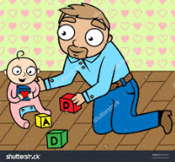
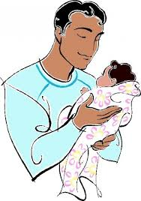

How did researchers know that an attachment had formed with the father?

Evaluation of multiple attachments and the role of the father
Point: The role of fathers as secondary attachment figures can be explained through biological processes and gender stereotyping.
Evidence: For example,

Evaluation: This is a strength because

Point: A weakness of the research into attachment figures is that there are inconsistent findings as to the role of the father in attachments.
Evidence: For example,

Evaluation: This is a problem because

Point: A further criticism is that research has left unanswered questions such as, if fathers have such a distinct role, why children without fathers are not different to those with.
Evidence: For example,

Evaluation: This is a strength because

