**Research into Minority Influence**

A01 - description

**Minority influence:**

**Key factors of success:**

**Research conducted by:**

**Aim:** To investigate the role of a _____________________ minority upon the levels of a majority in an ______________________ situation.

**Procedure:**

* ______________ participants were placed into groups of 6, 4 ______ participants, 2 _______________
* Participants were told it was an investigation into perception.
* Groups were shown ____ blue slides, varying in terms of colour intensity, all participants were required to answer the colour of the slide verbally in the presence of the group
* The real participants were in one of two conditions;

Consistent – Minority answered ___________ for ***______***36 slides;

Inconsistent – Minority answered green for ______/36 slides

* Each condition was compared to a control condition with ____ _________________ ____________________

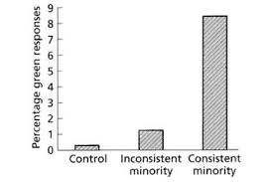

**Findings:**

**Consistent condition = %**

**Inconsistent condition = %**

**Control group = %**

**Conclusion:**

**Potential evaluation:**

A03 - evaluation

**Point: Further research demonstrates the impact of minority influence**

**Evidence:** **For example** an adaptation of Moscovici’s research was completed where participants were exposed to minority influence but were able to give answers privately. They found even higher levels of agreement with the minority that in the original research.

**Evaluation: This is positive because**

**Point: Moscovici’s research can be criticised for lacking ecological validity.**

**Evidence:**

**Evaluation:**

**Point:**

**Evidence: For example** the sample was populated by female participants which means that only the female response to minority influence was being assessed during the investigation.

**Evaluation:**