Clue card

Low population validity

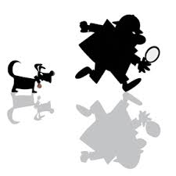

Clue card

Low ecological validity



Clue card

Lack of informed consent



Clue card

Lack of protection of participants



**For example –** Where was the research conducted? What type of behaviour would be shown?

**This is a weakness because –** Where can we not generalise the results to? Why?

**For example –** Who are the sample? What then, is the research testing? Who is not represented?

**This is a weakness because –** Who can we not generalise the results to? Why?

**For example –** How do you know the research lacked informed consent? What does this mean?

**This is a weakness because –** What could be the impact of not allowing your participants informed consent? (Think future research)

**For example –** How do you know the research lacked participant protection? What does this mean?

**This is a weakness because –** What could be the impact of not protecting your participants adequately? (Think future research)