Clue card

The learning theory provides an

adequate explanation

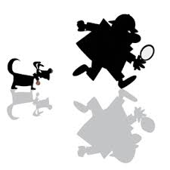

Clue card

Harlow’s research using monkeys

goes against the leaning theory



Clue card

There is evidence to suggest that

attachment is not learned



Clue card

There is evidence to suggests that

feeding is not key to attachment



**For example –** Watson & Raynor conditioned Little Albert to have a phobia of fluffy animals and toys through classical conditioning by banging a metal bar whenever he interacted with the fluffy toy.

**This is a strength because –** What principles of the learning theory can we see in the Watson and Raynor study? What does this suggest about learning? Is it possible we learn to attach?

**For example –** Lorenz found that newly hatched geese (after seeing Lorenz shortly after hatching) followed him everywhere and he became their ‘imprinted parent’

**This is a weakness because –** What does this suggest about *how* attachments occur? Could the geese have learned anything? How does this go against the learning theory?

**For example –** Shaffer & Emerson found that the first attachments formed by 39% of babies were **not** to the person who fed and changed them – they attached to those who played with them

**This is a weakness because –** What does this suggest about the main reason babies attach? What aspect of the learning theory does this go against?

**For example –** Harlow found that rhesus monkeys that were separated from their mothers after birth and were placed in a cage with ‘wire’ mothers went to the ‘mother’ who offered comfort rather than food

**This is a weakness because –** What does this suggest about *why* attachments occur? How does this go against the learning theory?