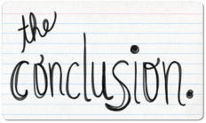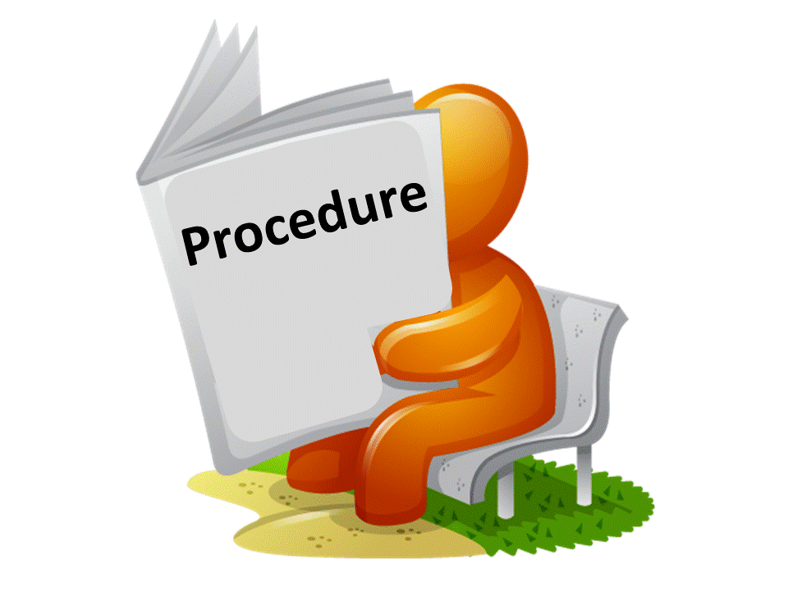

**Proactive Interference:**

**Findings:**

**Procedure:**

**Aim:**

**Retroactive Interference:**

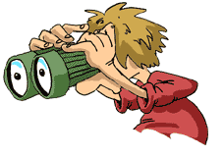

**Conclusion:**

**Evaluation**

**Point:** However, real-life studies have indicated support for the interference theory.

**Evidence:** Asked rugby players to recall the names of teams recently played. For various reasons including injuries and suspensions most players they interviewed had missed some games, so for one player the last game might have been last week, while for another it was two months ago. Baddeley and Hitch found that recall for the last game was equally good whether that game was played some time ago or last week. This shows that incorrect recall was not due to decay (the passage of time) but was related to the number of intervening games

**Evaluation:**

**Point:** However, a weakness of the interference theory is that it is most commonly tested using laboratory experiments.

**Evidence:**

**Evaluation:**

**Point:**

**Evidence:** Participants were divided into two groups. Group A were asked to learn a list of word pairs i.e. cat-tree, they were then asked to learn a second list of word pairs where the second paired word was different i.e. cat – glass. Group B were asked to learn the first list of word pairs only. Both groups were asked to recall the first list of word pairs. **Underwood and Postman** found that Group B recall of the first list was more accurate than the recall of group A.

**Evaluation:**