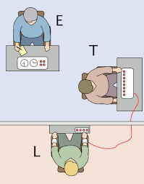
Factors affecting obedience rates

 | Factor – A01 | Link to research – A02/3
Situational factors  -external | Proximity | Where can the influence of proximity be seen in one of the variations of Milgram’s research?
 | Location | Where can the influence of location be seen in one of the variations of Milgram’s research?
 | Uniform
Dispositional factors-internal | The Authoritarian Personality

