**Research into Compliance**

A01 - description

**Conformity:**

**Compliance:**

[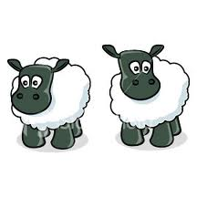](http://images.google.co.uk/imgres?q=sheep+following+cartoon&hl=en&safe=vss&tbo=d&biw=1280&bih=843&tbm=isch&tbnid=JGWXpDks57hsVM:&imgrefurl=http://www.zdnet.com/blog/feeds/dont-be-sheep-follow-your-peers-not-necessarily-the-a-list/1095&docid=Lrba1HbXe7b4AM&imgurl=http://www.zdnet.com/i/story/61/46/001095/ist2_1282664-cartoon-sheep.jpg&w=270&h=270&ei=o6vFULyMHISLhQeR-4BY&zoom=1&iact=hc&vpx=2&vpy=118&dur=369&hovh=216&hovw=216&tx=104&ty=125&sig=114289821477472485908&page=1&tbnh=130&tbnw=122&start=0&ndsp=39&ved=1t:429,r:0,s:0,i:83)

**Research conducted by:**

**Aim:** To investigate if participants would change their own views to conform to the majority when participants were confronted with a majority who were plainly wrong in their answers

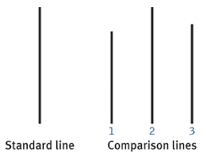

**Procedure:**

* **_______ American male undergraduate ____________**
* In small groups (between __________) they were shown **a series of lines** they were asked to identify which of the comparison lines was ___________ in length to the standard line
* All but one of the participants were **“____________________”**, the real participant was ________ or last but one to answer
* Asch instructed the confederates to answer the ________ _______________ answer on ___/___ trials (known as ____________ trials)
* A ____________ group was created of 36 participants who answered individually, without ___________ _________________ for comparison

**Findings: Control group – Experimental group - - -**

**Conclusion:**

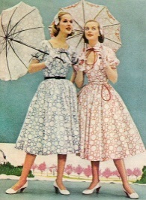

**Potential evaluation:**

A03 - evaluation

**Point:**

**Evidence:** **For example**

**Evaluation: This is positive because** it suggests that the IV (agreement of the confederates) was the only variable affecting the DV (______________) allowing a cause and effect relationship to be established giving the study high ___________ validity.

**Point:**

**Evidence:** Asch’s study was conducted in 1950s America during McCarthyism (strong anti-communist time) when people were scared to be different.

**Evaluation:**

**Point:**

**Evidence: For example**

**Evaluation:**