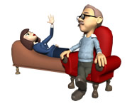
You be the Cognitive Psychologist!

Zac is playing a computer game which involves sorting coloured shapes that appear on the screen. He has to capture and drag them to the appropriate collection box. While he plays, he chats to Dan about a football match.

When he has completed Level 1, he moves on to Level 2. Here, the shapes are replaced by words that have to be sorted according to their meaning. Zac begins to make mistakes and so stops talking to Dan.

With reference to features of the working memory model, explain why Zac can easily cope with Level 1 and chat to Dan but, when he gets to Level 2, he cannot do both things at the same time.
(6 marks)

_________________________________________________________________________________________________________________________________________________________________________________________________________________________________________________________________________________________________________________________________________________________________________________________________________________________________________________________________________________________________________________________________________________________________________________________________________________________________________________________________________________________________________________________________________________________________________________________________________________________________________________________________________________________________________________________________________________________________________________________________________________________________________________________________________________________________________________________________________________________________

